PRACTICE TASK CLASS -8
SED COMMAND

- search and replace pattern only 1 st occurance and all the occurance
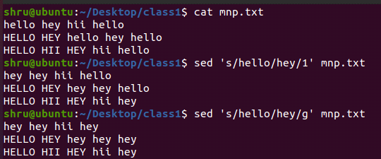
- search and replace pattern on particular line and all the line
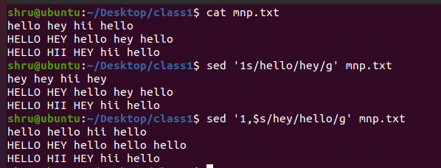
- print and delete the particular line with the pattern
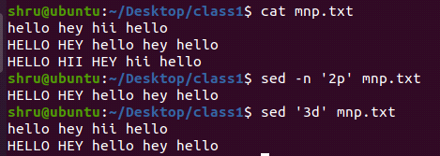
- delete the pattern inside all the line and delete the line with the pattern

